Based on the provided structure, here's a more detailed breakdown for a slide presentation:

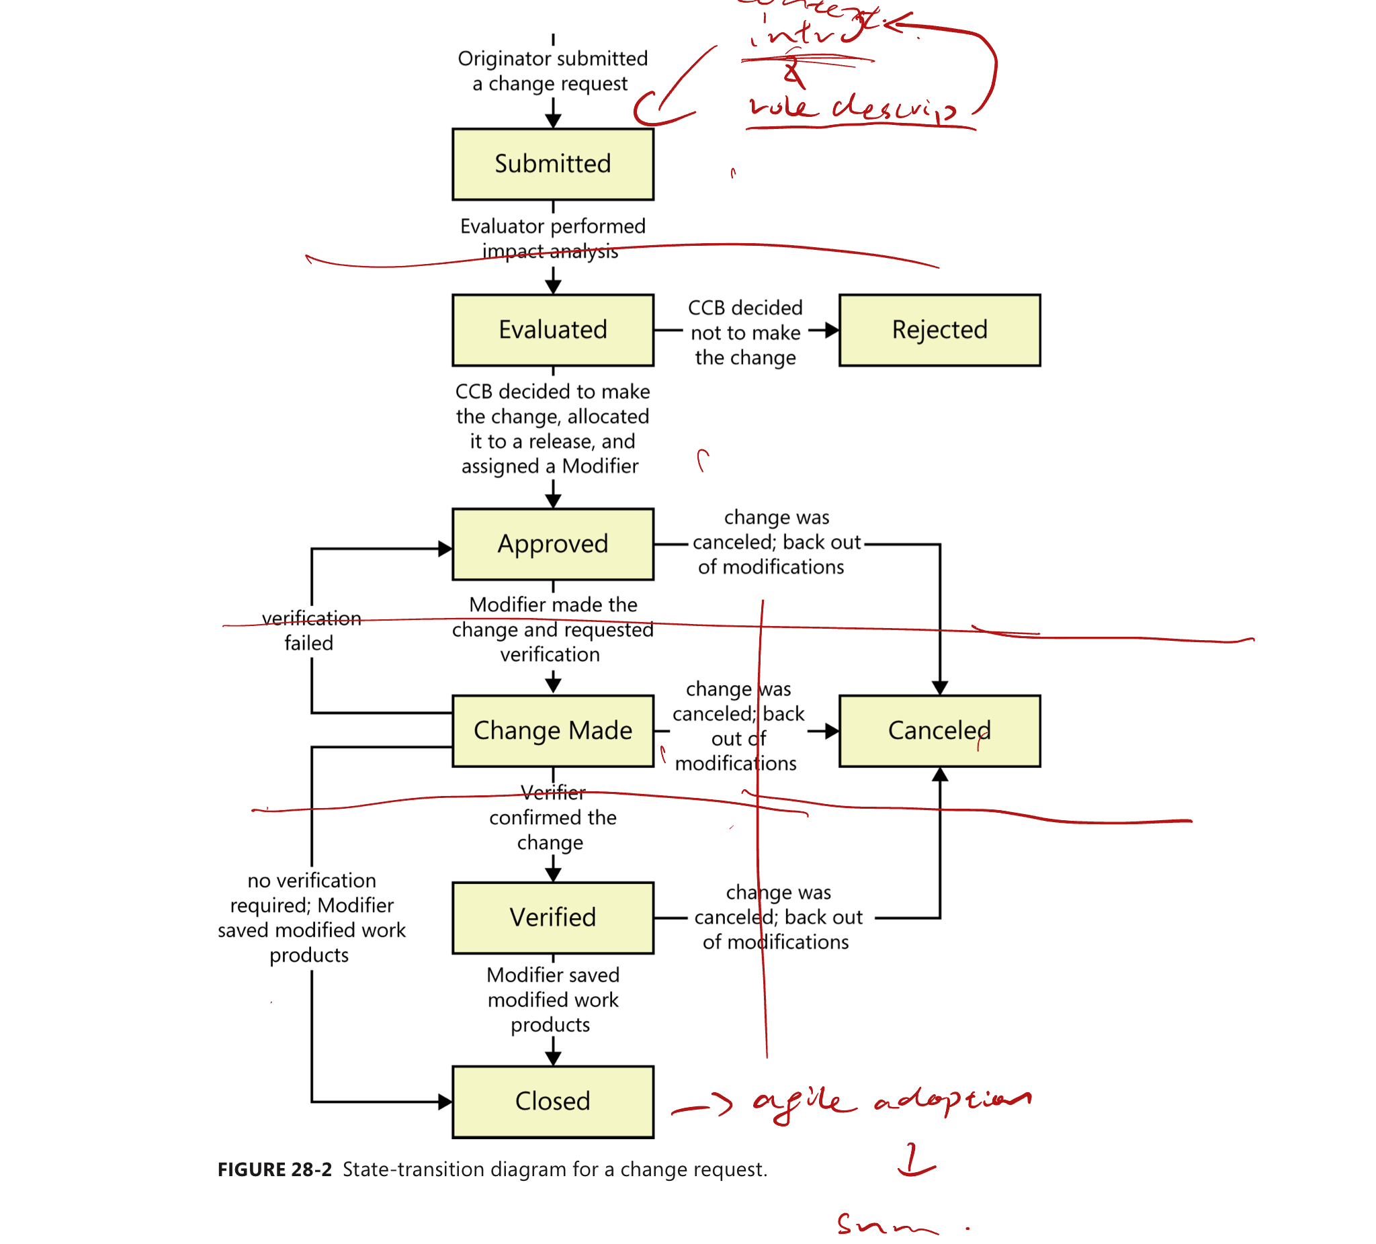

### Slide 1: Introduction and context

- Title: Introduction to Requirement Change Management

- Brief overview of the importance of managing requirement changes

- Objectives of the presentation

—----------------------------------------------------------------------------------------------------------

Conor

### Slide 2: Role Description

- Definition of roles involved in requirement change management (e.g., Project Manager, Business Analyst, Stakeholders)

- Responsibilities of each role in the process

### Slide 3: Submission Process

- Step-by-step process of submitting a requirement change

- Tools and templates used for submission

- Importance of clear and detailed submission

—-----------------------------------------------------------------------------------------------------------

Automata丶

### Slide 4: Evaluation Process

- Criteria for evaluating a requirement change

- Role of the evaluation team

- Timeline and steps involved in the evaluation

### Slide 5: Rejection Criteria

- Common reasons for requirement change rejection

- Communication process for rejected changes

- Steps to reconsider or refine a rejected change

—----------------------------------------------------------------------------------------------------------------

Sihui He

### Slide 6: Approval Process

- Criteria for approval of a requirement change （这个部分感觉是evaluation做的）

- Decision-making process and authorities involved

- Communication of approval

### Slide 7: Cancellation Stage

- Scenarios where a requirement change might be canceled

- Process and communication for canceling a change

- Impact assessment and stakeholder notification

ISO/IEC/IEEE 29148:2018 - Systems and software engineering — Life cycle processes — Requirements engineering

“Overview of the change management approval process” https://docs.bmc.com/docs/change2102/overview-of-the-change-management-approval-process-973921970.html

“The Definitive Guide to Approval Processes“ https://kissflow.com/workflow/approval-process/

“ABCs of Requirements Engineering“ https://www.cmcrossroads.com/article/abcs-requirements-engineering

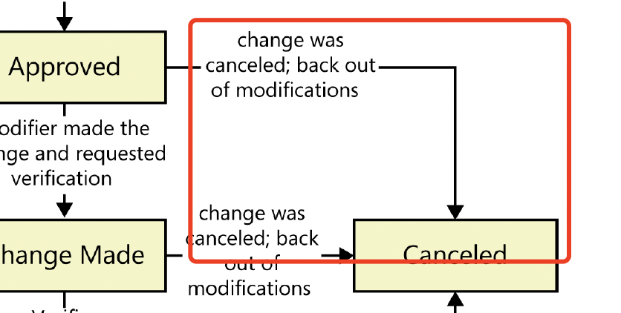

—---------------------------------------------------------------------------------------------------------

Allen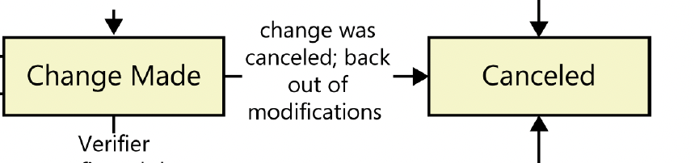

Slide 8: Implementing Changes

1. Steps to Implement the Approved Requirement Changes:

* Identification and Documentation: Clearly document the change, including its scope, impact, and the rationale behind it.
* Impact Analysis: Assess how the change will affect different aspects of the project, including timelines, resources, and other requirements.
* Update Requirement Specifications: Revise the requirement specifications to reflect the approved changes. Ensure that the changes are clear and unambiguous.
* Communicate Changes: Inform all stakeholders and team members about the changes. Communication should include why the change was made and how it impacts various aspects of the project.

1. Coordination Among Teams and Integration into the Current Project Plan:

* Cross-Team Coordination: Ensure that all teams are aligned with the change. This may involve meetings, updates to project plans, and adjustments to team responsibilities.
* Integration with Current Plans: Adjust the project plan, schedules, and resource allocations to accommodate the change. Ensure that the integration is seamless and does not disrupt ongoing work.

1. Monitoring and Controlling Changes During Implementation:

* Track Implementation: Regularly monitor the progress of the change implementation to ensure it is aligned with the project plan.
* Quality Assurance: Conduct testing and reviews to ensure that the change meets the required standards and does not introduce new issues.
* Adjustments and Iterations: Be prepared to make further adjustments as the change is implemented, responding to any unforeseen issues or feedback.

Slide 9: Change Cancellation and Approval Review

1. Reviewing the Reasons and Impacts of Canceling Changes:

* Assessment of Cancellation Reasons: Discuss why a change is being considered for cancellation—whether due to feasibility, cost, or a shift in project priorities.
* Impact Analysis: Evaluate the consequences of canceling the change, including how it will affect the project's scope, timeline, and stakeholder expectations.

1. Finalizing Approvals and Integrating Changes into the Project:

* Approval Process: Outline the process for finalizing the decision to cancel a change, including who needs to sign off and how the decision will be communicated.
* Integration or Reversion: Depending on whether the change is canceled or approved after review, describe the steps to either integrate the change into the project or revert back to the previous plan.

1. Documentation and Record-Keeping for Future Reference:

* Comprehensive Documentation: Ensure that all decisions, along with their rationales and impacts, are thoroughly documented. This includes documenting the reasons for canceling a change and the lessons learned from the process.
* Knowledge Sharing: Discuss how this documentation will be stored and shared within the organization to inform future projects and decisions.
* Audit Trail: Emphasize the importance of maintaining a clear audit trail for accountability and for reviewing the project's history.

—------------------------------------------------------------------------------------------------------------

Chun Yang

### Slide 10: Verification of Changes

- Verification process to ensure changes align with requirements

- Quality control and testing methodologies

- Stakeholder feedback and final acceptance

### Slide 11: Closing and Cancellation

- Formal process for closing out implemented changes

- Documentation and lessons learned from the change process

- Conditions and process for canceling a closed change

### Slide 12: Agile Adoption in Change Management

- Importance of agility in requirement change management

- Adopting agile practices in the change process

- Benefits and challenges of agile adoption

—------------------------------------------------------------------------------------------------------------

### Slide 13: Summary and Conclusion

- Recap of the key points covered in the presentation

- Final thoughts on effective requirement change management

- Encouraging continuous improvement and adaptability in change processes

### Slide 14: Q&A

- Opening the floor for questions and discussions

- Providing contact information for further inquiries

This detailed slide structure should provide a comprehensive overview of requirement change management, allowing for an in-depth exploration of each aspect of the process.